
Kirirom Institute of Technology

Freelancing in Cambodia

Name: San Thornen

Major: Software Engineering

Batch: 8 C

Subject: Theory of Computation

Professor: Mr. Dinesh Kumar

25th August 2021

Introduction
We would like to do a brief introduction in Cambodia, before we get started, How much do you know about Cambodia?. Cambodia is famous for its Angkor Wat, Cambodia is in the the southeast part of Indochina, the east Cambodia touches Vietnam, the north touches Laos, the northwestern part touches Thailand and the south touches the Thailand bay. Despite Cambodia's growing rapidly lately , It is currently one of the poorest countries in the world. its per-capita income is only $260. Cambodia is a developing country, so there are many issues that this country needs to address. Moreover During Current Covid 19 pandemic, Cambodia is now facing many challenges and it has a great impact on the economy and the livelihood of the citizen, Social distancing was implemented, Province and City was lockdown, Markets, Restaurant, Shop, etc were closed which were the source of income of the people. People have to stay indoors, so they cannot earn income to feed themselves and their family. They have no choice but to move their business from physical to digital. Many Cambodians now earn income from broadcasting live on facebook, promoting and selling their products online, But Some of those online sellers are teachers, artists, etc, as a result they are not putting their skill in good use.So that is why, I am proposing a topic “Freelancing in Cambodia” which I think can address some of the issues that people are facing during this pandemic and they can earn income freelancing their skills and staying safe at home at the same time. But before that we should see in depth the problems that Cambodia is facing and how freelancing can solve those problems.

Poverty in Cambodia

Cambodia has made substantial progress over the last two decades, achieving lower middle-income status in 2015 and aiming for upper middle-income status by 2030. Cambodia's economy, driven by garment exports and tourism, grew at an average real rate of 7.7% between 1998 and 2019, making it one of the world's fastest-growing economies. In 2020, the global shock caused by the COVID-19 pandemic had a substantial impact on Cambodia's economy, at a time when Cambodia is also facing the partial suspension of preferential access to the EU market under the "Everything But Arms" initiative. Most of Cambodia's main engines of growth—tourism, manufacturing exports, and construction dramatically as a result of the outbreak—which together accounted for more than 70 percent of the country’s growth in 2019 and almost 40 percent of paid employment. In 2020, the economy grew at a negative rate of -3.1 percent, the steepest drop in Cambodia's recent history. Cambodia's economy is predicted to begin to recover this year, with growth of 4%, thanks to improved external environment and unprecedented government support. The COVID-19 outbreak and slow recovery in global economic activity, alongside prolonged financial market turmoil, poses risks to Cambodia’s growth outlook. The World Bank and the National Institute of Statistics created and are conducting high-frequency household phone surveys in Cambodia to track COVID-19's effects at the household level. The fourth round of surveys, conducted in December 2020 and January 2021, revealed that 72 percent of respondents were employed, which was close to the levels seen in May and August 2020 but still lower than the pre-pandemic average of 82 percent. In addition, 50 percent of households reported a decrease in household income from the previous round, according to the December 2020 poll.

Employment During Covid 19

Construction, manufacturing, hotels and restaurants, transportation, storage and communications, financial intermediation, real estate, and business activities are the sectors most at risk of job losses. Under the IMF scenario, approximately 60% of those who lose their jobs would become unemployed, raising the unemployment rate from 0.7 percent in 2019 to 3.2 percent in 2020, and 4.4 percent under the ADB-MEF joint scenario, a relatively small number (18,000 – 25,000, or 5%) would drop out of the labor force, while the remaining 35% (140,000 – 200,000) would shift to lower-productivity sectors with low incomes and poor working conditions (mainly in agriculture and to a lesser extent in wholesale and retail trade). The results reveal that between 390,000 and 570,000 employment could be lost in 2020, exacerbating informality and vulnerability. Lockdown measures have resulted in firm closures and labor stoppages, as well as aggregate demand decreases and supply chain disruptions, both directly and indirectly. The COVID-19 pandemic is having unprecedented impacts on the Cambodian labor market, similar to other countries in Southeast Asia. Economic activity has already slowed down considerably, which will translate into weak labor market performance. Cambodia's real Gdp growth is projected to be negative (-1.6 percent) in 2020, according to revised IMF predictions . This decline in output is significantly worse than the country's performance during the Great Recession, when growth slowed dramatically but remained positive at 0.1 percent in 2009. In 2020, the joint ADB-MEF modeling exercise predicts an even worse drop in real GDP (-5.5 percent).
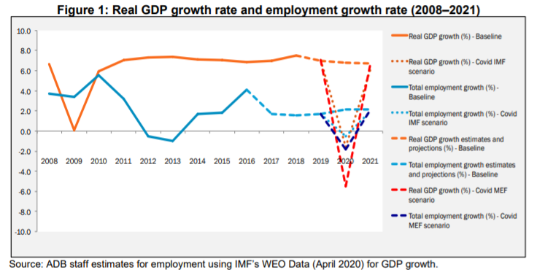
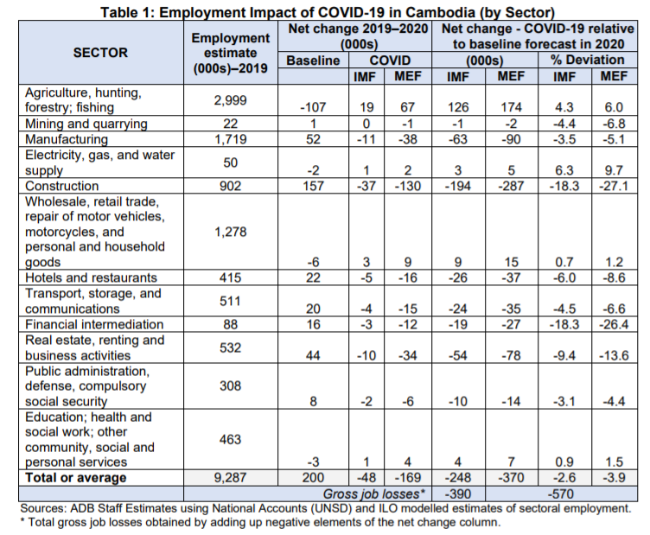
The sectors most affected in terms of projected employment losses are construction, manufacturing, hotels and restaurants, transport, storage and communications. These sectors, categorized as having either a medium or high risk in terms of the potential COVID-19 impact, as per the monitoring update of the International Labour Organization (ILO)9 , accounted for approximately 60% of value added and nearly 45% of employment in Cambodia in 2019. For example, the tourism industry (which spans multiple industries) accounts for 750,000 people, whereas the garment industry (which falls under manufacturing) employs 800,000. External demand shocks resulting from the global pandemic are putting a strain on both tourism and garments, which is becoming evident in 2020. In terms of tourism, approximately half of Cambodia's 6.6 million visitors came from the People's Republic of China (PRC), and with the outbreak of COVID-19, arrivals from PRC dropped sharply. ADB estimates for the overall employment impact shows that in comparison with the baseline estimate for 2020, employment levels would be lower by about 63,000-69,000 in manufacturing, 26,000–37,000 in hotels and restaurants, 24,000–35,000 in transport, storage and communications, over 54,000–78,000 in real estate and business activities, and 19,000-27,000 in financial intermediation (Table 1).
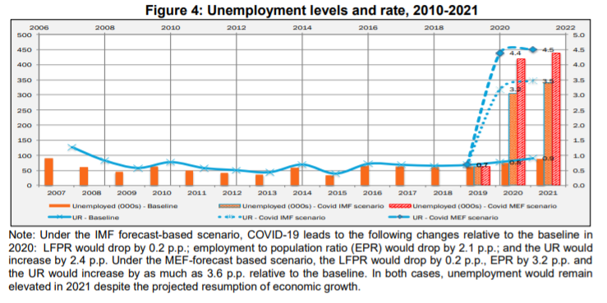

Solution

The solution is to create Freelancing websites like upwork or freelancer for Cambodians. Since transferring money from foreign countries to Cambodia has an expensive fee, that's why our freelancing website should accept ABA pay, Wing Pay, Visa, Pi Pay, etc . This should be convenient for both local employers and freelancers. Importantly our freelancing website should have a legit and proper rating system to be a trustworthy platform for both employers and freelancers.

Advantages of being a freelancer:

- Freedom of Clients : Freelancers are able to choose the clients they work with, and create networking with many clients
- Control of workload : Freelancers are able to choose their workload, they can work as much or as little as they want
- Flexibility
- Independence
- Exposure : Working as freelancers can open up the ability to work on a variety of projects and topics. This variety can help create an environment that is less redundant and boring

Existing Solution

There are actually freelancing websites in Cambodia also and they are freelancecambodia.com, khmerlancer.com etc.

freelance.com
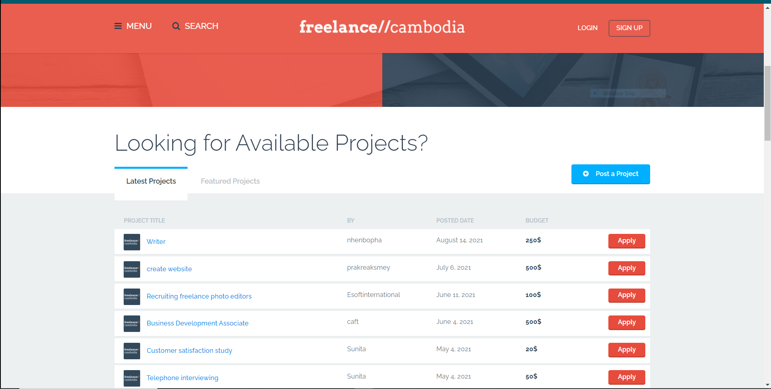

khmerlancer.com



These websites are great but many Cambodians aren't aware of them yet and there is no proper rating system in those websites, so that will make me or other employer hesitate to hire those freelancers since we are not so sure if they are trustworthy or not. Compared to our freelancing website we will do heavily digital marketing to bring awareness of our services to Cambodians.

ER diagram

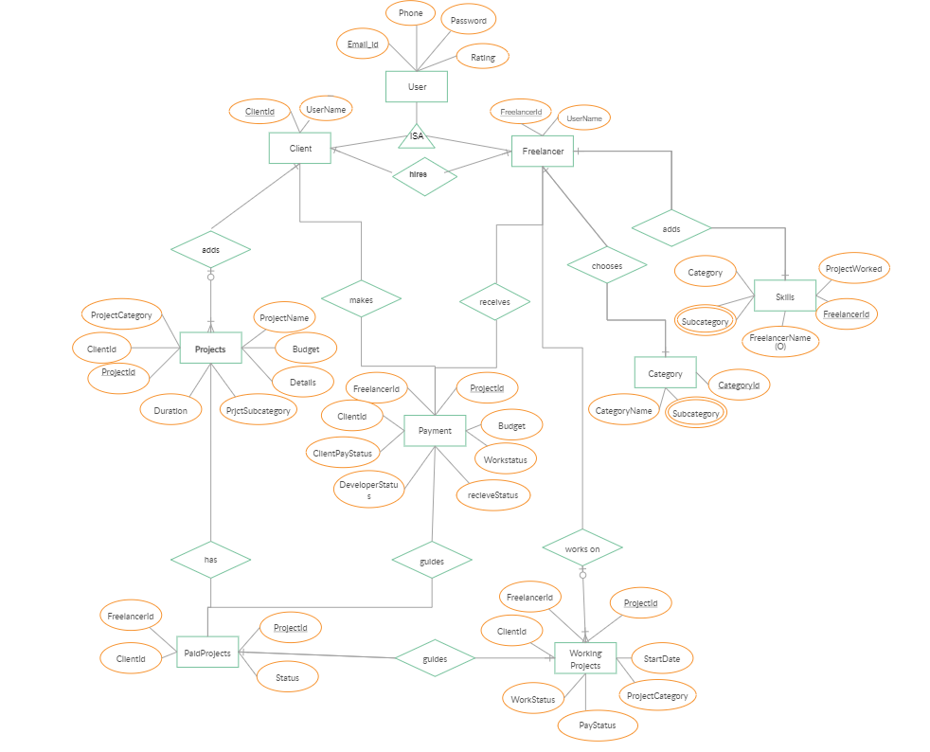

Conclusion

In conclusion, Cambodia is a developing country, there are many issues that it has to address. In this Covid 19 pandemic, it has a big impact on the country's economy and livelihood of the people. People cannot earn much income, businesses are out of business or halt. People are not putting their skills to good use and freelancing is able to address some of those issues that people are facing.

Reference

WorldBank article about Development news, research, data of Cambodia

https://www.worldbank.org/en/country/cambodia/overview#1

RRP Cam article about Employment and Poverty impact assessment: Cambodia

https://www.adb.org/sites/default/files/linked-documents/54195-001-sd-03.pdf
Jessica Howington article about the Pros and Cons of freelancing

https://www.flexjobs.com/blog/post/pros-and-cons-of-freelance-jobs/
Creately ER diagram of freelancing website

https://creately.com/diagram/iv6yws921/New%20E-R%20Diagram%20for%20Freelancing%20Website

